**Concepts of effective web design**

Like the phrase ‘beauty is in the eye of the beholder’, effective web design is judged by the users of the website and not the website owners. There are many factors that affect the usability of a website, and it is not just about form (how good it looks), but also function (how easy is it to use).

**1. Purpose**

Good web design always caters to the needs of the user. Are your web visitors looking for information, entertainment, some type of interaction, or to transact with your business? Each page of your website needs to have a clear purpose, and to fulfill a specific need for your website users in the most effective way possible.

## 2. Communication

People on the web tend to want information quickly, so it is important to communicate clearly, and make your information easy to read and digest. Some effective tactics to include in your web design include: organising information using headlines and sub headlines, using bullet points instead of long windy sentences, and cutting the waffle.

## 3. Typefaces

In general, Sans Serif fonts such as Arial and Verdana are easier to read online (Sans Serif fonts are contemporary looking fonts without decorative finishes). The ideal font size for reading easily online is 16px and stick to a maximum of 3 typefaces in a maximum of 3 point sizes to keep your design streamlined.

## 4. Colours

 well thought out colour palette can go a long way to enhance the user experience. Complementary colours create balance and harmony. Using contrasting colours for the text and background will make reading easier on the eye. Vibrant colours create emotion and should be used sparingly (e.g. for buttons and call to actions). Last but not least, white space/ negative space is very effective at giving your website a modern and uncluttered look.

## 5. Images

A picture can speak a thousand words, and choosing the right images for your website can help with brand positioning and connecting with your target audience. If you don’t have high quality professional photos on hand, consider purchasing stock photos to lift the look of your website. Also consider using infographics, videos and graphics as these can be much more effective at communicating than even the most well written piece of text.

## 6. Navigation

Navigation is about how easy it is for people to take action and move around your website. Some tactics for effective navigation include a logical page hierarchy, using bread crumbs, designing clickable buttons, and following the ‘three click rule’ which means users will be able to find the information they are looking for within three clicks.

## 7. Grid based layouts

Placing content randomly on your web page can end up with a haphazard appearance that is messy. Grid based layouts arrange content into sections, columns and boxes that line up and feel balanced, which leads to a better looking website design

## 8. “F” Pattern design

Eye tracking studies have identified that people scan computer screens in an “F” pattern. Most of what people see is in the top and left of the screen and the right side of the screen is rarely seen. Rather than trying to force the viewer’s visual flow, effectively designed websites will work with a reader’s natural behaviour and display information in order of importance (left to right, and top to bottom).

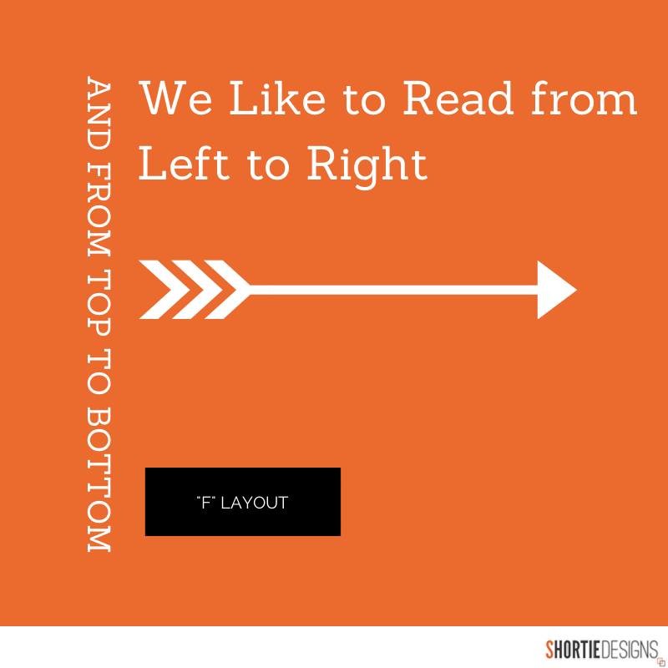

## 9. Load time

Everybody hates a website that takes ages to load.  Tips to make page load times more effective include optimising image sizes (size and scale), combining code into a central CSS or JavaScript file (this reduces HTTP requests) and minify HTML, CSS, JavaScript (compressed to speed up their load time)

## 10: Mobile friendly

It is now commonplace to access websites from multiple devices with multiple screen sizes, so it is important to consider if your website is mobile friendly. If your website is not mobile friendly, you can either rebuild it in a responsive layout (this means your website will adjust to different screen widths) or you can build a dedicated mobile site (a separate website optimised specifically for mobile users).

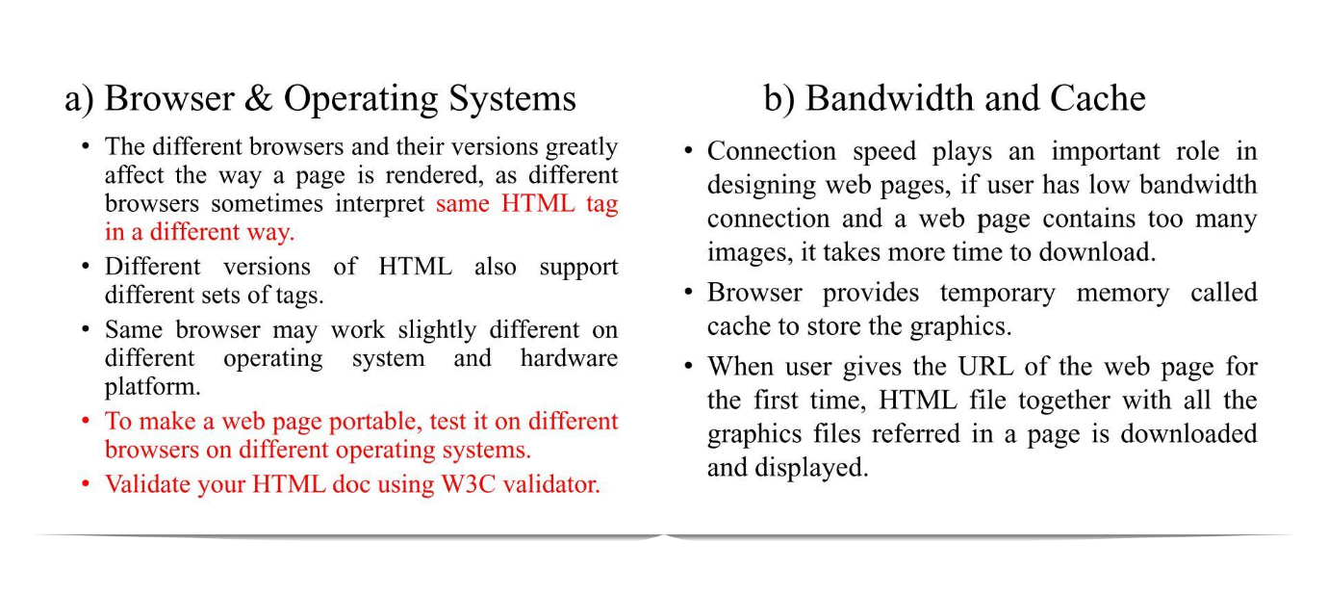

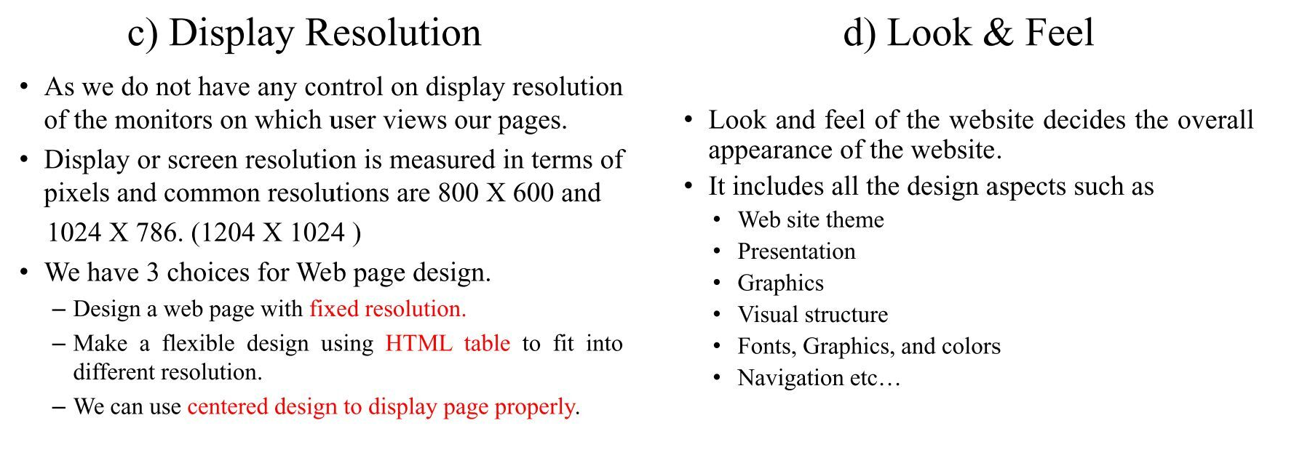

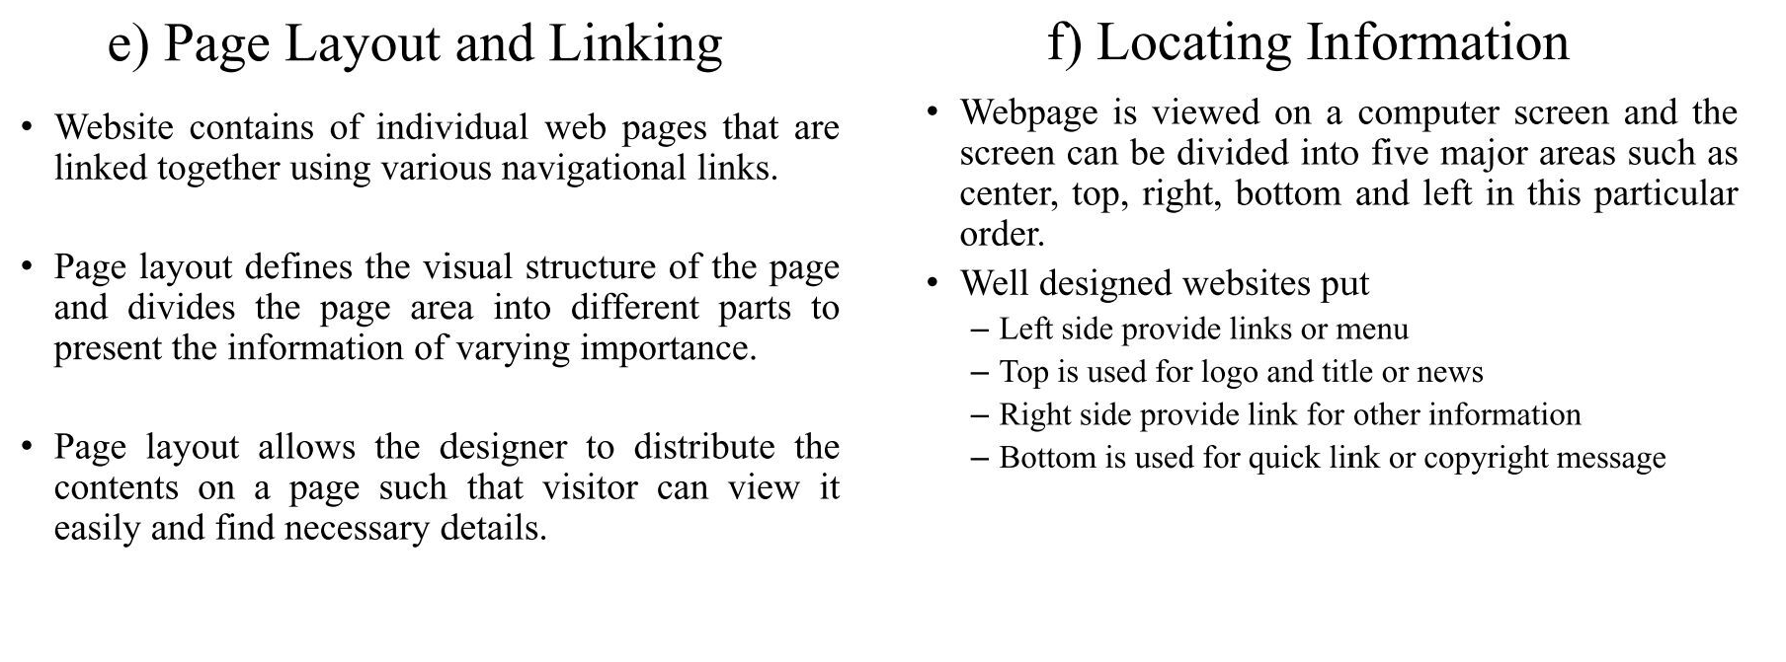 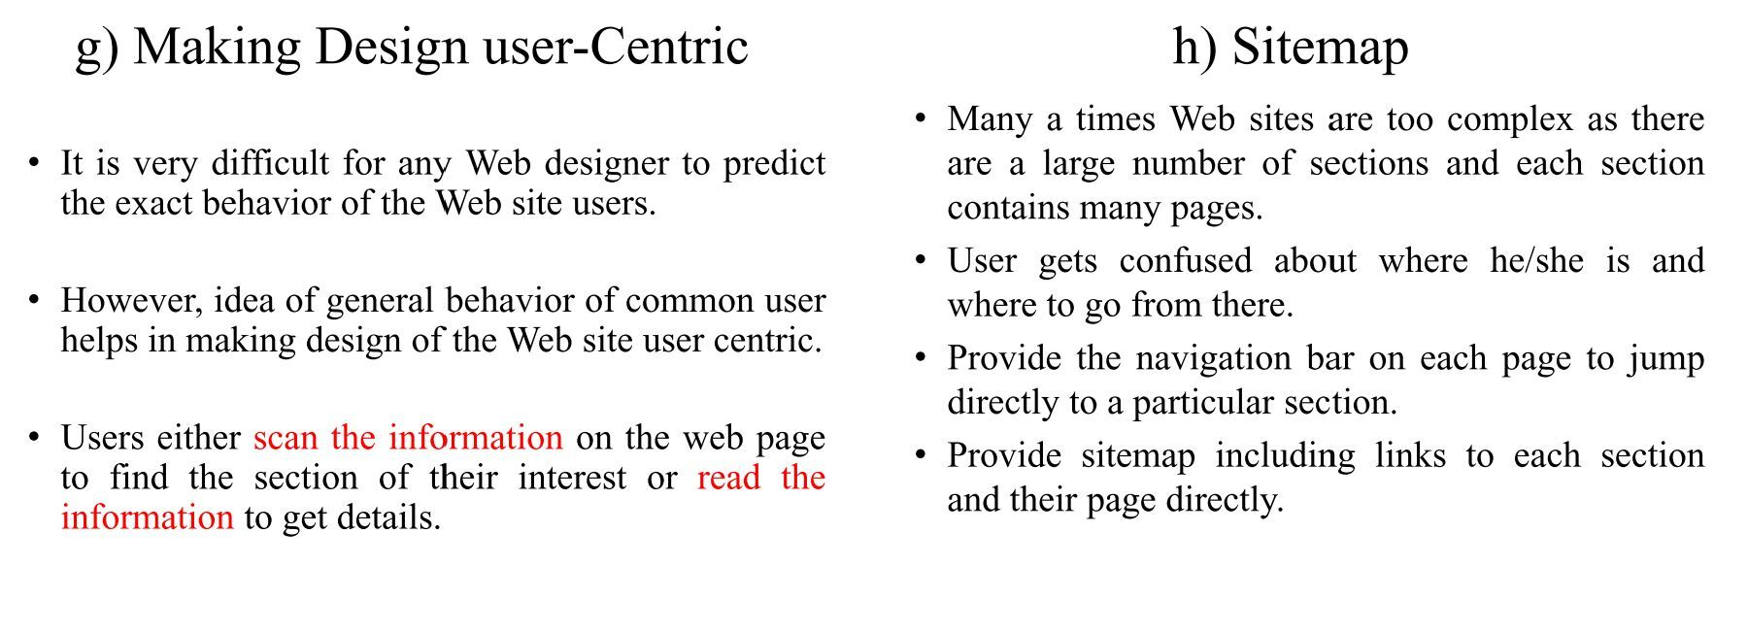

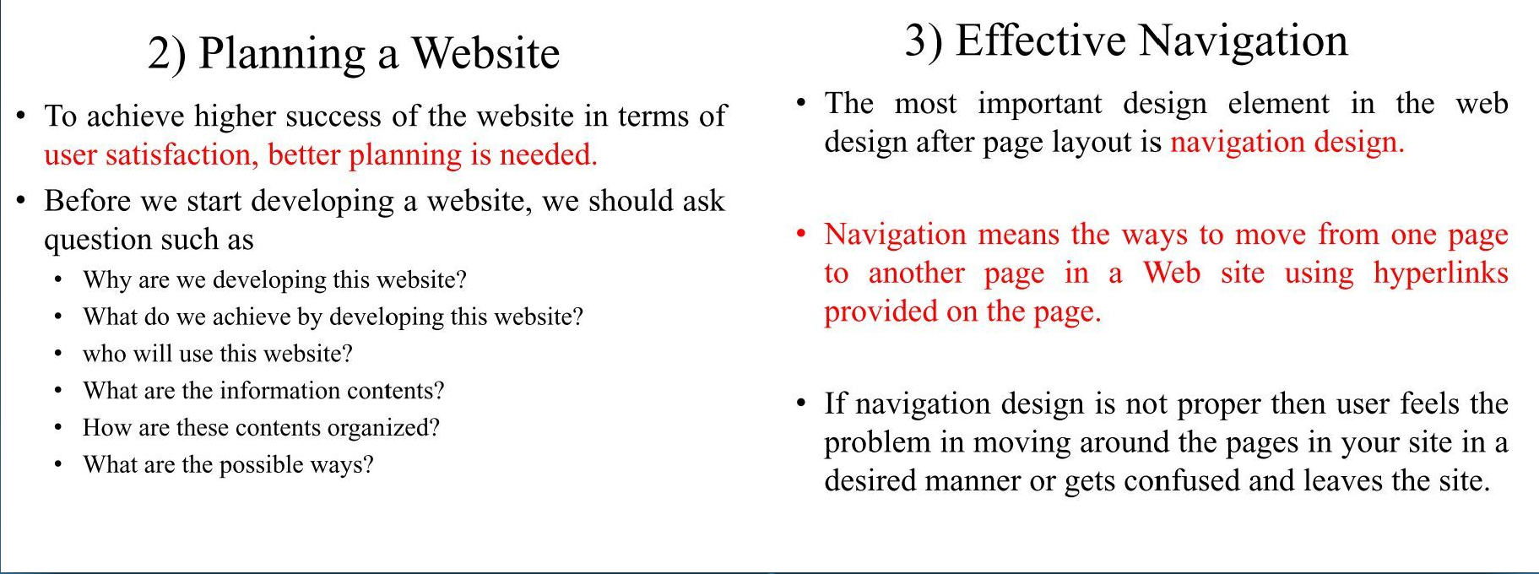

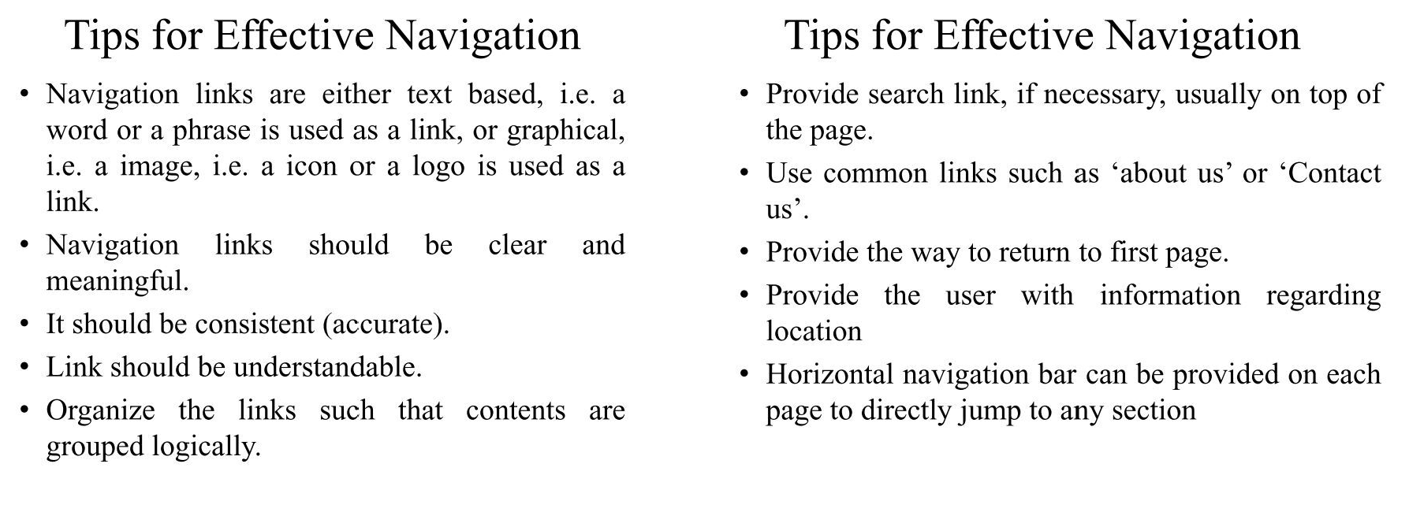

Browser architecture

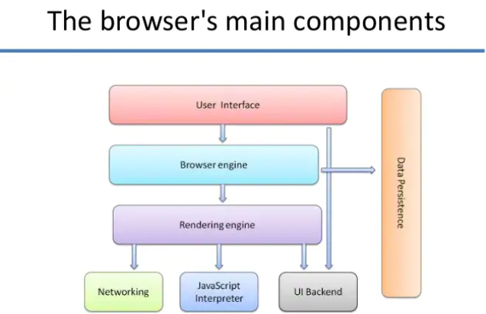

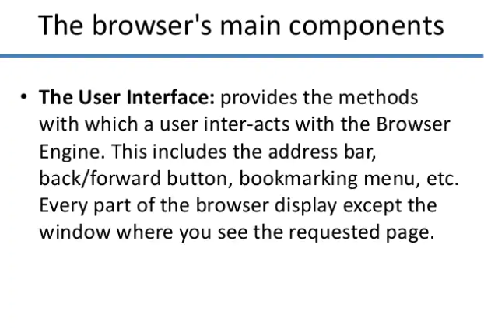 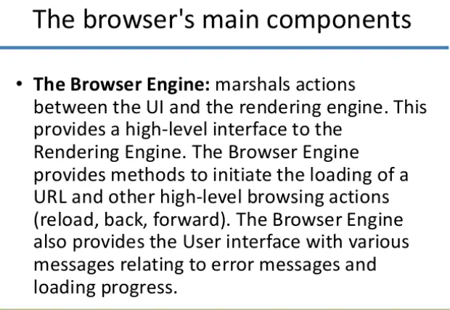

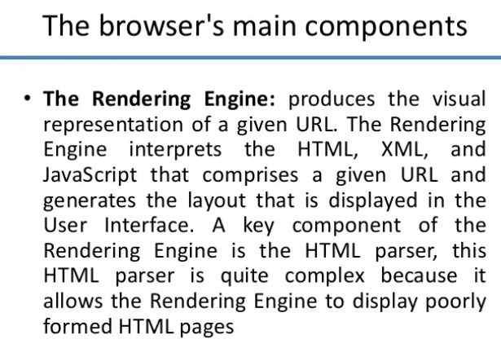

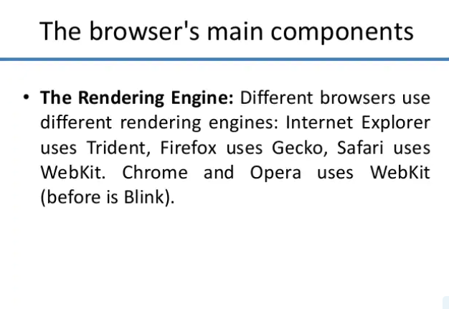 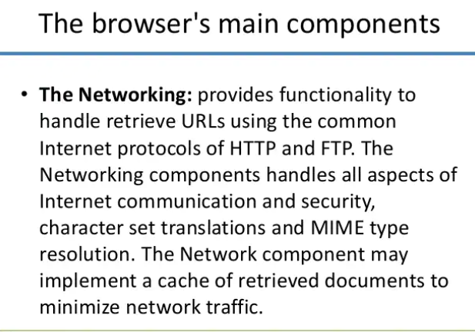

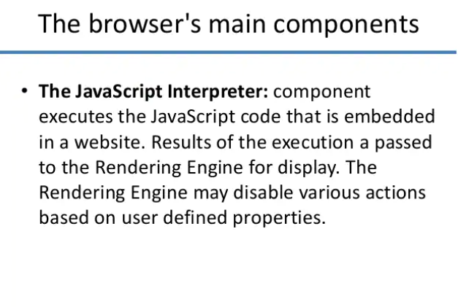 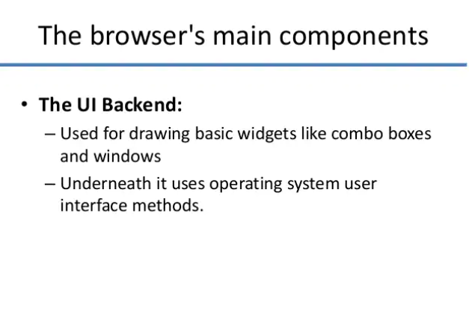 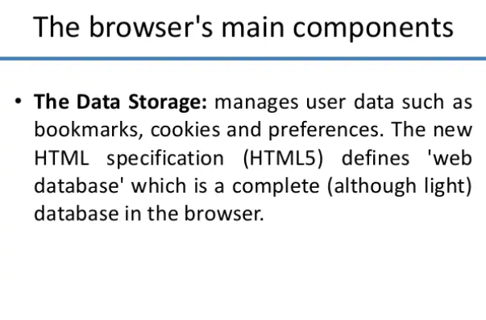

# **What is Website structure? Why structure is important?**

Starting a blog/website nowadays is not a difficult task but increasing its visibility and improving rank is the huge task we face afterward. This is the biggest challenge for bloggers, small businesses, and personal website owners.

Websites with loading time more than 3 sec results in higher bouncing rate and that’s where website structures comes in the role.

As we know a well-structured city enables its residents to roam around in a strategic manner helping them find their way, such is the case with the website.

A website is made of various pages and posts and it [needs](https://www.marketing91.com/needs-wants-and-demands/) to be categorized in an excellent website structure which will enable the users to navigate through all the content easily.

Website structure refers to the way a website is set up i.e. how the homepage, category and tags pages and other important pages are interconnected.

Ideal site structure of any site should resemble a pyramid with homepage at the top and categories with subcategories beneath it.

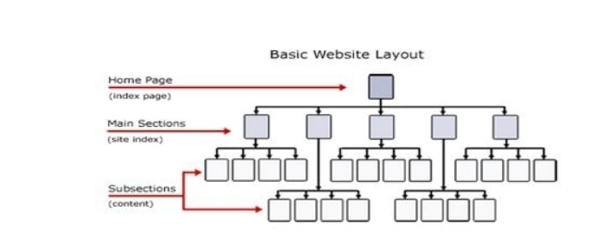

User’s attention span is very short in this fast-paced internet so your site structure should mainly focus on providing a great experience to your users and to enable search engines crawlers to properly crawl your website for faster indexing (to rank in search engines such as [Google](https://www.marketing91.com/google-swot-analysis/)).

you need to think about your [target](https://www.marketing91.com/swot-analysis-target/) audience while deciding your site structure.

The unstructured website will lead to higher [bounce rate](https://www.marketing91.com/bounce-rate/) resulting in lower visibility of your site. While better site structures result in higher ranking in search engines as for how a site is structured is an important ranking signal for Google.

Google algorithm takes information from users to rank any site.

So, if a user dwells on any website for the longest time which happens due to good site structure, it results in lowering of bounce rate eventually improving the rank of the site.

**Overview and features of HTML5.**

HTML is a language for describing the structure of Web pages. HTML stands for HyperText Markup Language. Web pages consist of markup tags and plain text. HTML5 is the next generation of HTML.

Since the early days of the web, there have been many versions of HTML

|  |  |
| --- | --- |
| HTML | 1991 |
| HTML 2.0 | 1995 |
| HTML 3.2 | 1997 |
| HTML 4.01 | 1999 |
| XHTML | 2000 |
| HTML5 | 2014 |

### **What is HTML5?**

HTML5 is the new standard for HTML. The previous version of HTML, HTML4.01, came in 1999. The web has changed a lot since then. HTML5 is still a work in progress. HTML5 has defined a new standard for HTML, XHTML, and the HTML DOM.

HTML5 is not something completely new. Most of the HTML5 specifications came from HTML or HTML1.0. A web browser can read HTML files and compose them into visible or audible web pages.

### **Features in HTML5 are**

* The DOCTYPE declaration for HTMl5 is very simple, <!DOCTYPE html>
* The character encoding<meta charset=”UTF-8”>
* New function for embedding audio(<audio>), video(<video>), graphics(<svg> and<canvas>)
* Client-side data storage
* Interactive documents
* New structural elements <article> ,<header>,<footer>,<nav>,<section>,and<figure>
* New from control calendar, date,time,email,url,search
* Java script enhancement
* New HTML5 API’s
* HTML Geolocation, HTML Drag And Drop, html local storage, HTML Application Cash, HTMl Web Workers, HTML SSE

### **HTML5 Browser support**

The latest versions of Apple Safari, Google Chrome, Mozilla Firefox, Opera, and Microsoft Internet Explorer 9.0 along with Microsoft Edge, all support many of the new HTML5 features.

**Overview and features of CSS3**

